**TZIV DU5**

**L = {a^3n b^2n | n € N}**

**Epsilon, aabb, aaaaaabbbb**

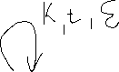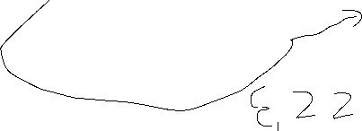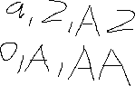

**A**

**A A**

**A A**

**A -> A**

**A Z**

**A**

**Z**

**3. L = { w= uv, #_(w=#_)w,u€{a,C}**

**V € {a, }\***